

**Faculty of engineering - Shoubra**

**Benha University Research Project**

in fulfillment of the requirements of

|  |  |
| --- | --- |
| **Department** | Engineering Mathematics and Physics |
| **Division** | **-----------** |
| **Academic Year** | 2019-2020 Preparatory |
| **Course name** | Computer |
| **Course code** | ECE001 |

**Title:**

**Artificial Intelligence**

By:

|  |  |  |  |
| --- | --- | --- | --- |
|  | Name | Edu mail | B.N |
| 1 | سلمى عبد الفتاح محمد | Salma195436@feng.bu.edu.eg | 392 |

**Approved by:**

|  |  |
| --- | --- |
| Examiners committee | Signature |
| Dr.Ahmed Bayoumi |  |
| Dr.Shady Elmashad |  |
| Dr. Abdelhamid Attaby |  |
|  |  |
|  |  |

**INTRODUCTION**

Artificial Intelligence (AI), the study and engineering of intelligent machines capable of performing the same kinds of functions that characterize human thought. The concept of AI dates from ancient times, but the advent of digital computers in the 20th century brought AI into the realm of possibility. AI was conceived as a field of computer science in the mid-1950s. The term AI has been applied to computer programs and systems capable of performing tasks more complex than straightforward programming, although still far from the realm of actual thought. While the nature of intelligence remains elusive, AI capabilities currently have far-reaching applications in such areas as information processing, computer gaming, national security, electronic commerce, and diagnostic systems.

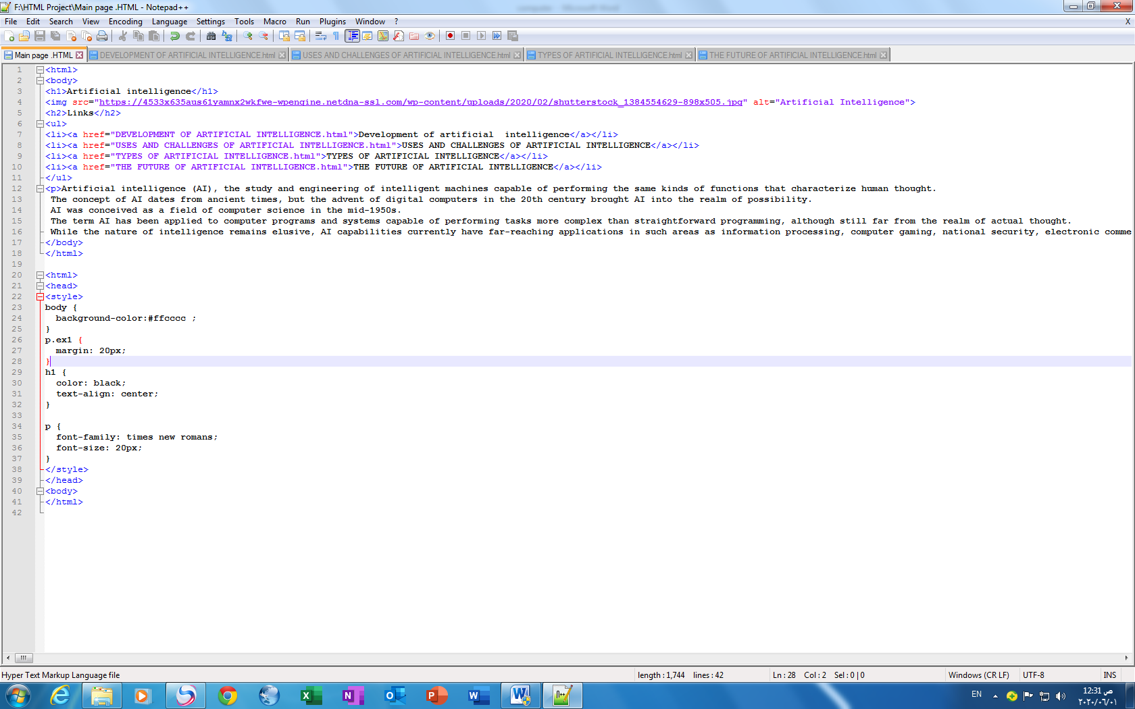

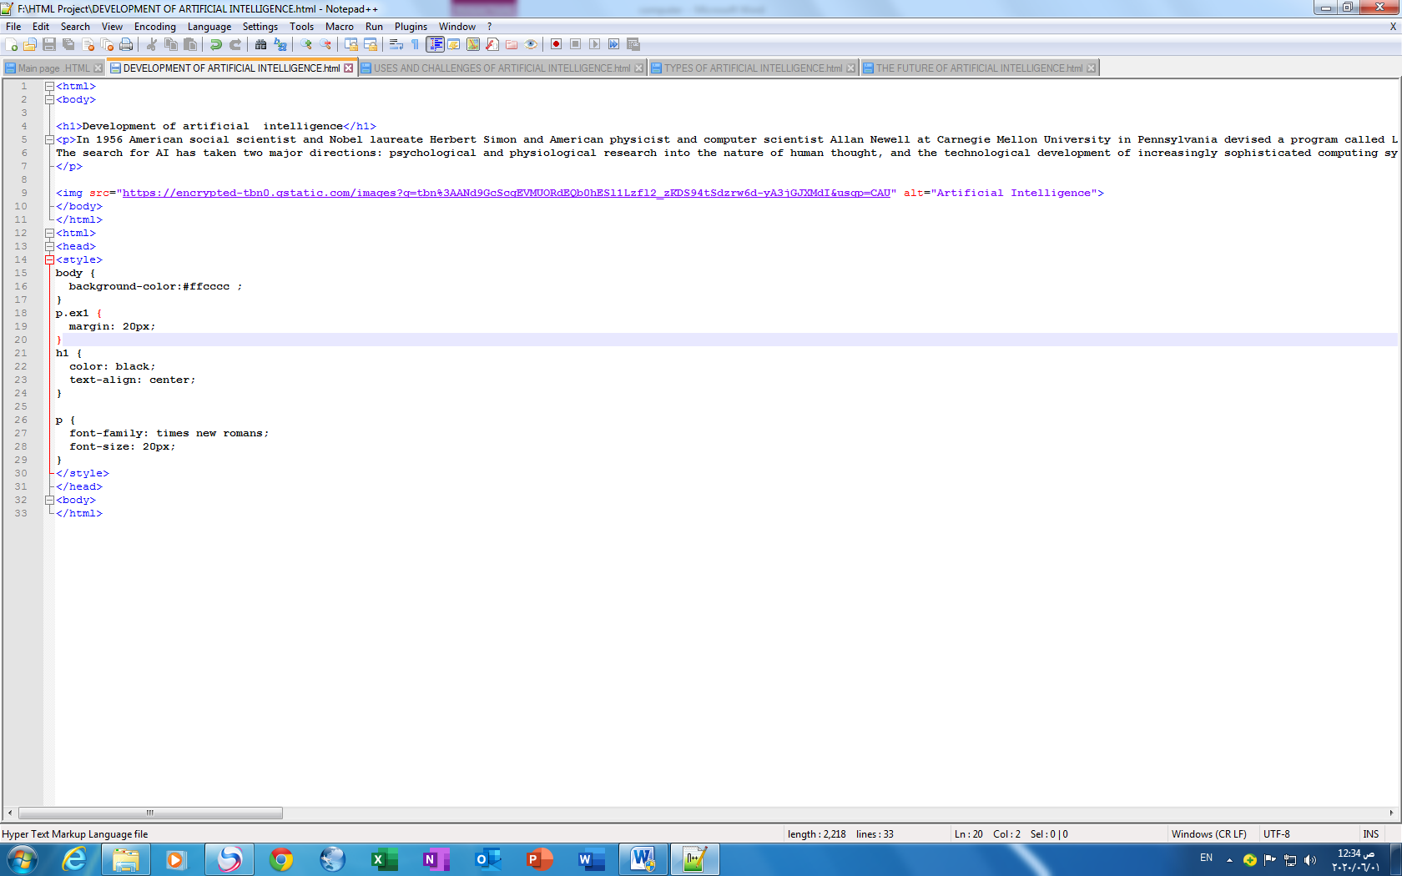

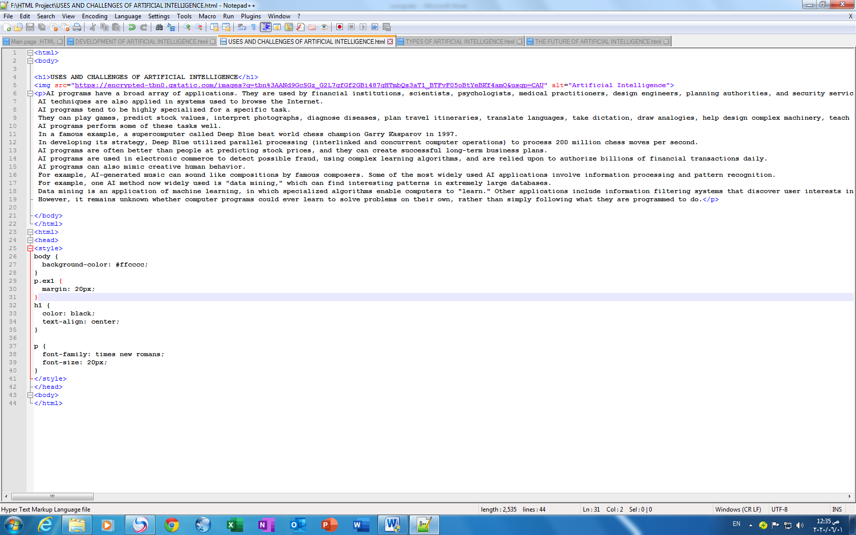

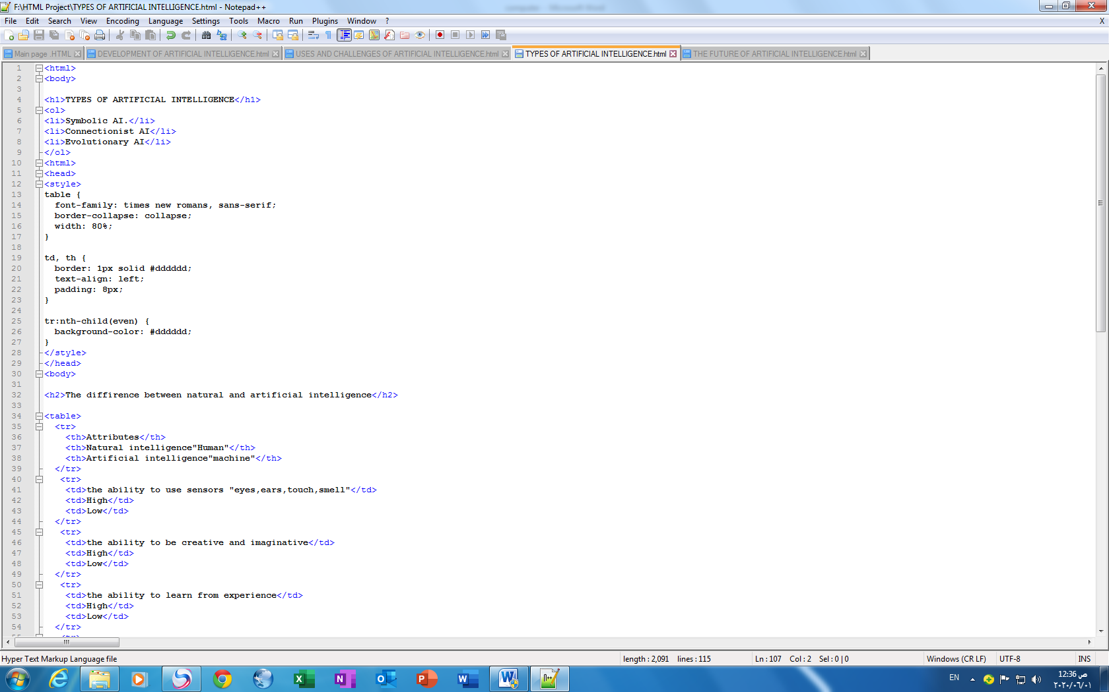

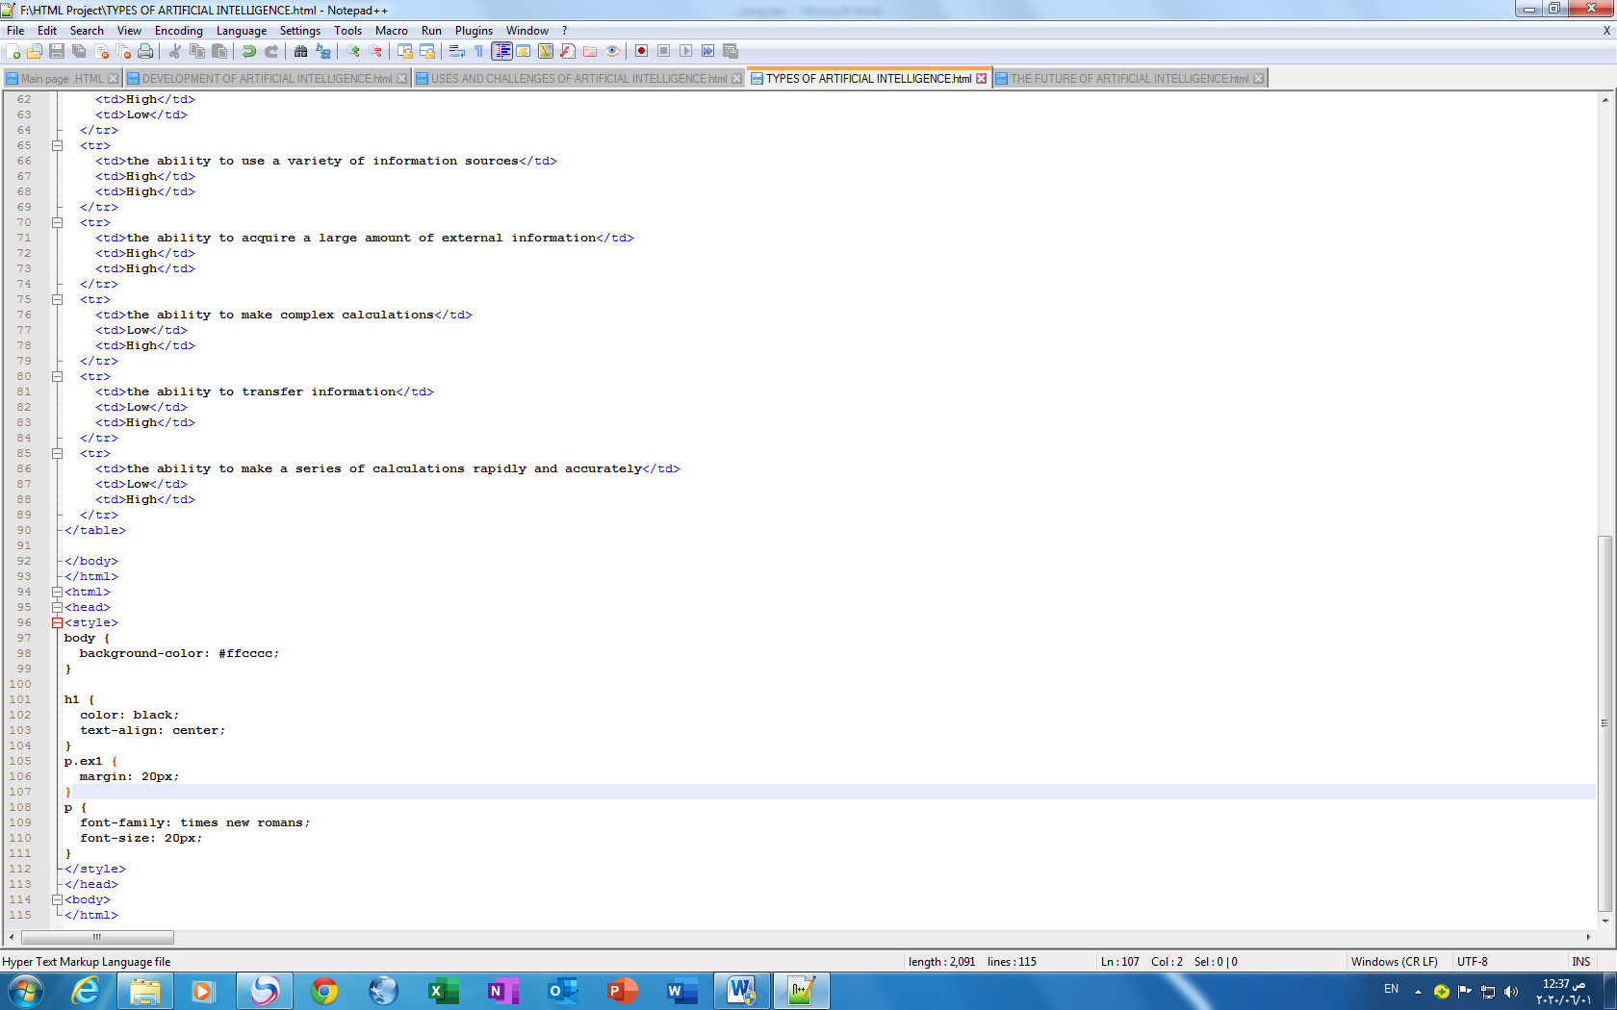

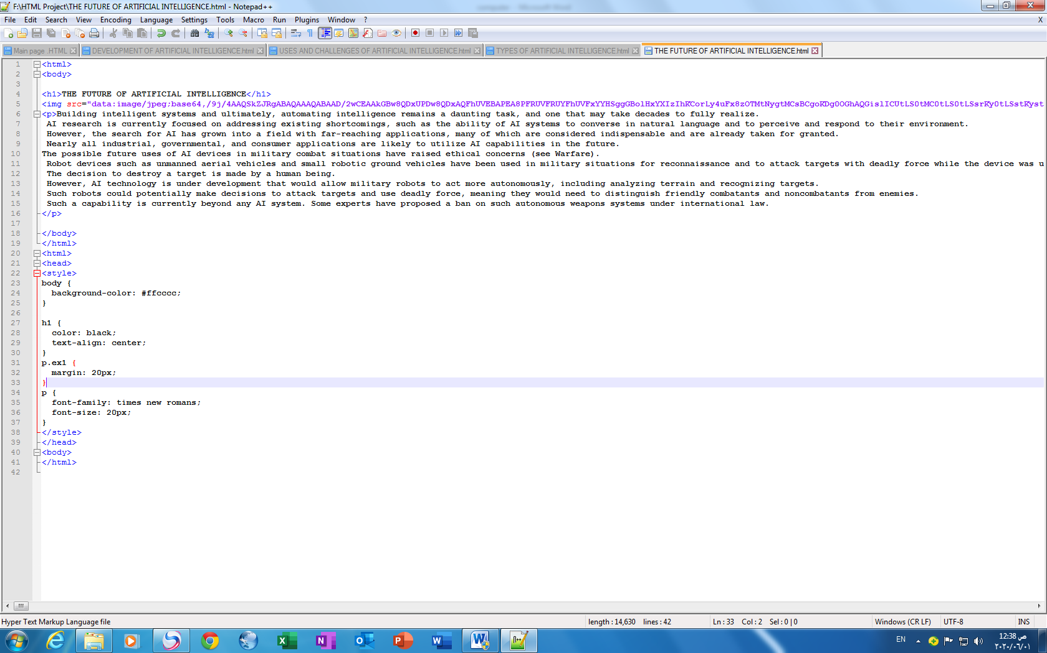

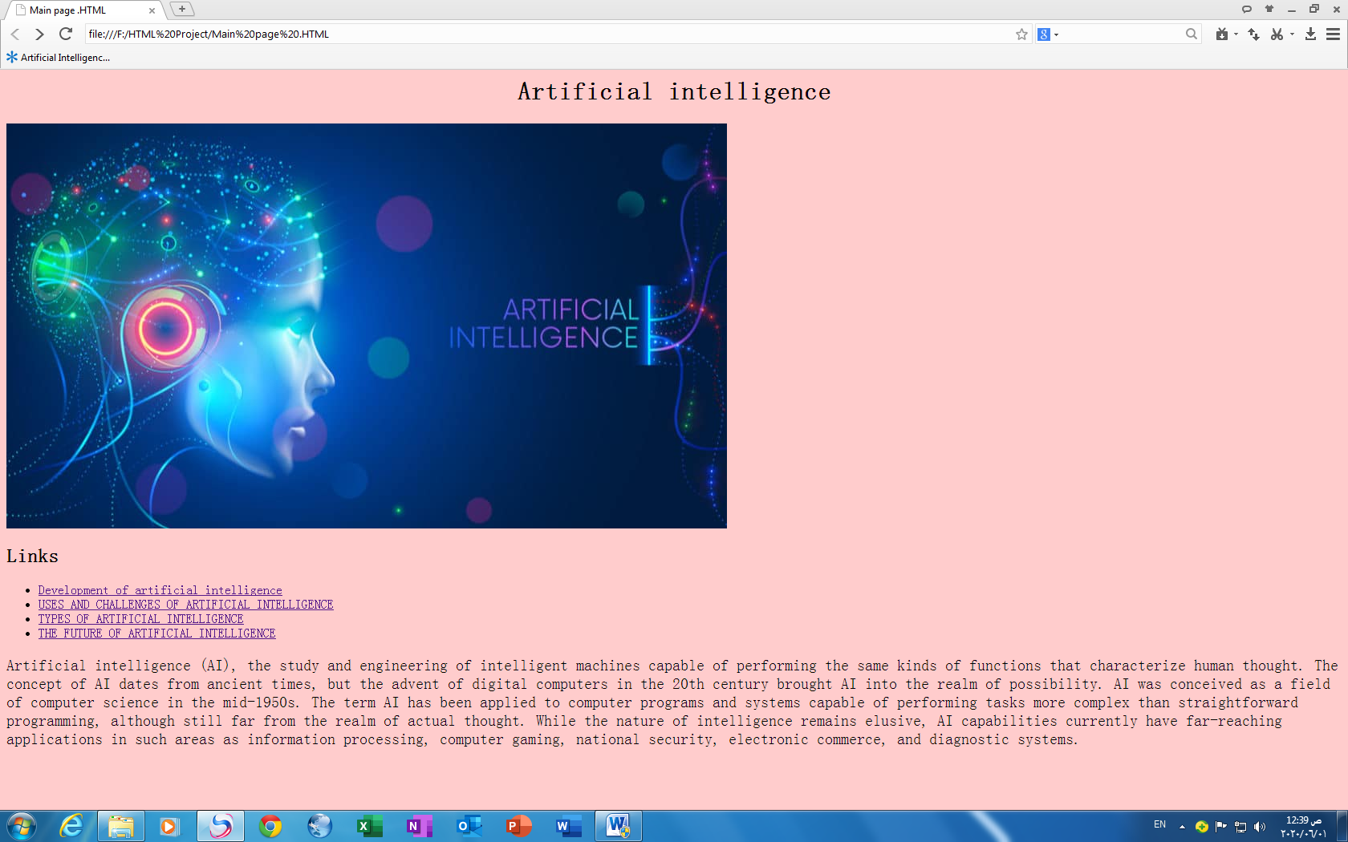

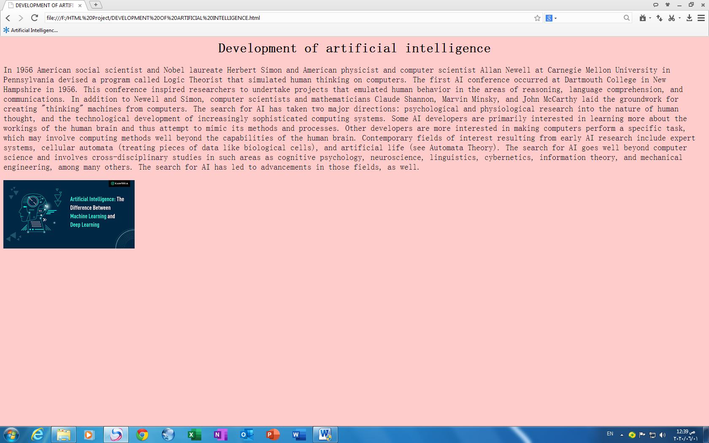

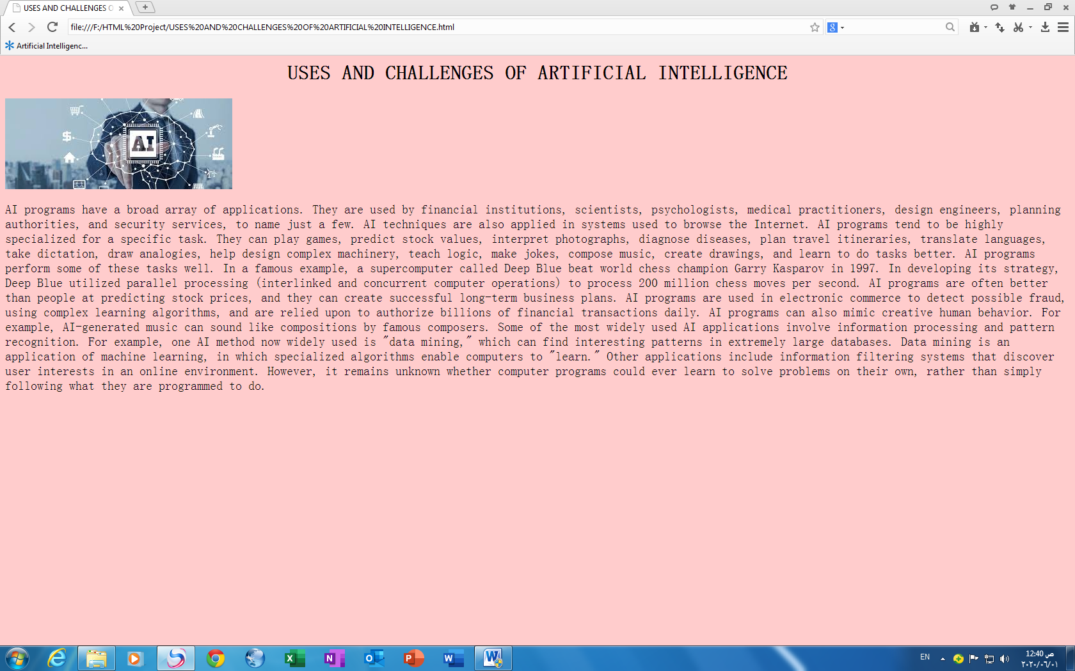

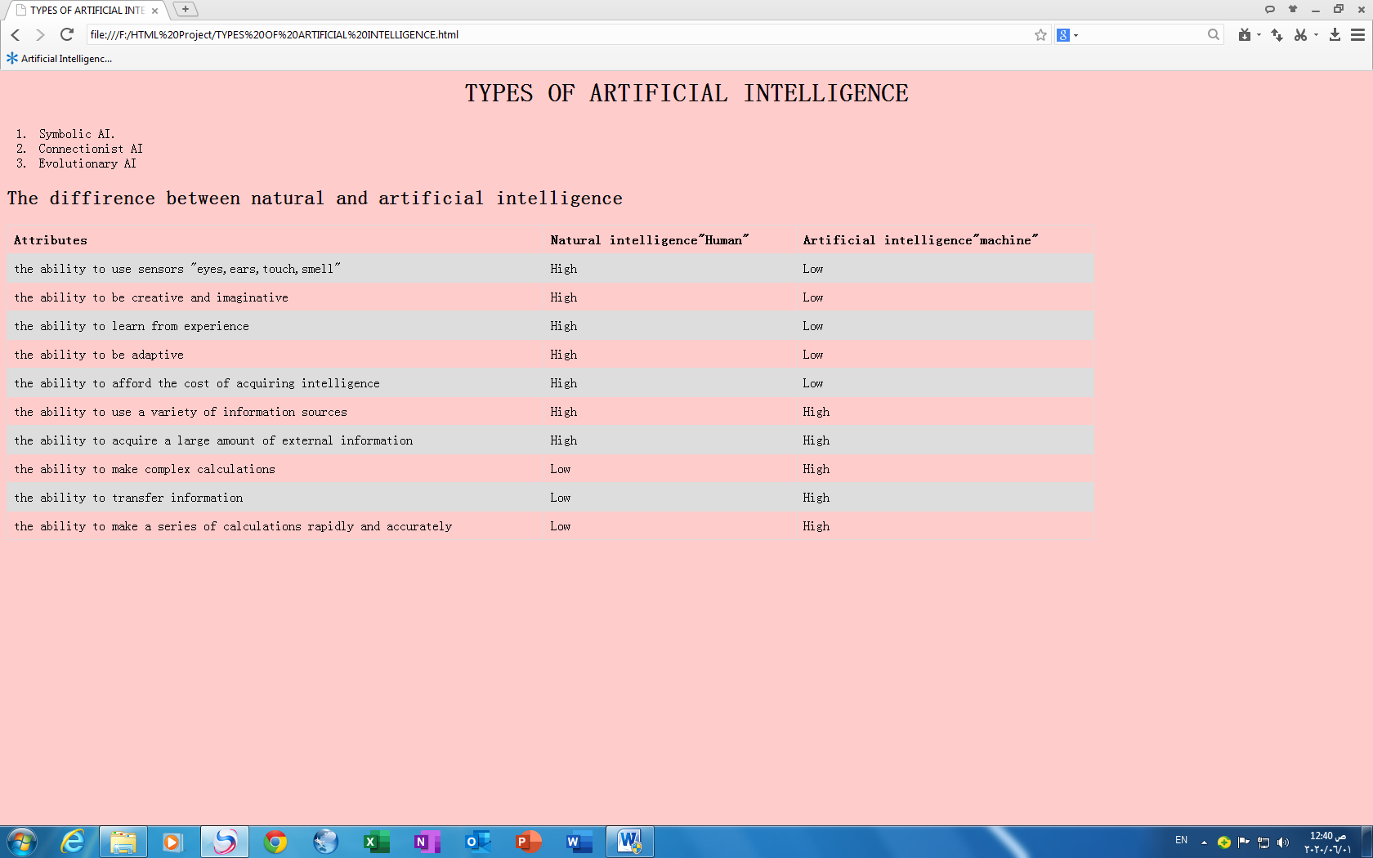

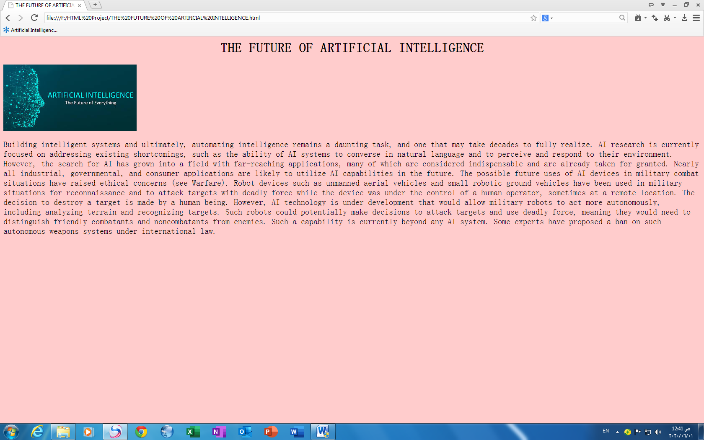

**Refrences**

1-Benefits & Risks of Artificial Intelligence - Future of Life Institute

<https://futureoflife.org/background/benefits-risks-of-artificial-intelligence/>

2-artificial intelligence | Definition, Examples, and Applications | Britannica

<https://www.britannica.com/technology/artificial-intelligence>

3-Artificial Intelligence | Electrical Engineering and Computer Science | MIT OpenCourseWare

<https://ocw.mit.edu/courses/electrical-engineering-and-computer-science/6-034-artificial-intelligence-fall-2010/>

4-Artificial Intelligence - Journal - Elsevier

<https://www.journals.elsevier.com/artificial-intelligence>

5-What is artificial intelligence?

<https://www.brookings.edu/research/what-is-artificial-intelligence/>